**Ideation Phase**

**Define the Problem Statements**

|  |  |
| --- | --- |
| Date | 20 June 2025 |
| Team ID | LTVIP2025TMID37089 |
| Project Name | Sustainable Smart City Assistant using IBM Granite LLM |
| Maximum Marks | 2 Marks |

**Customer Problem Statement Template:**

Create a problem statement to understand your customer's point of view. The Customer Problem Statement template helps you focus on what matters to create experiences people will love.

A well-articulated customer problem statement allows you and your team to find the ideal solution for the challenges your customers face. Throughout the process, you’ll also be able to empathize with your customers, which helps you better understand how they perceive your product or service

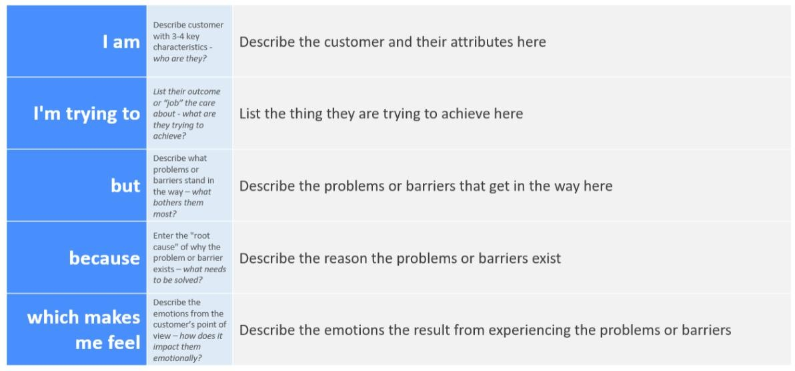

Example:



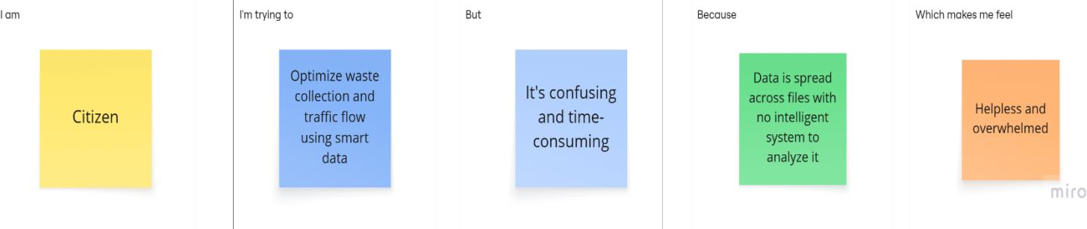

|  |  |  |  |  |  |
| --- | --- | --- | --- | --- | --- |
| **Problem Statement (PS)** | **I am**  **(Customer)** | **I’m trying to** | **But** | **Because** | **Which makes me feel** |
| PS-1 | A municipal officer  managing city waste | track waste generation and plan smart disposal routes | I can't make sense of the raw  data easily | there is no AI- based system for visual insights or route optimization | stressed and inefficient |
| PS-2 | A daily  commuter in the city | find a faster and less  congested route | traffic data is outdated and  not helpful | the system doesn’t analyze real-time coordinates | frustrated and  delayed |